Spring Data JPA Hands-On

Exercise 1: Spring Data JPA Configuration & Model

File: Country.java
Java
package com.cognizant.ormlearn.model;import jakarta.persistence.*;
@Entity@Table(name="country")public class Country {
@Id
@Column(name="co_code")
private String code;
@Column(name="co_name")
private String name;
// Add getters, setters, and toString()
}
Output Screenshot:
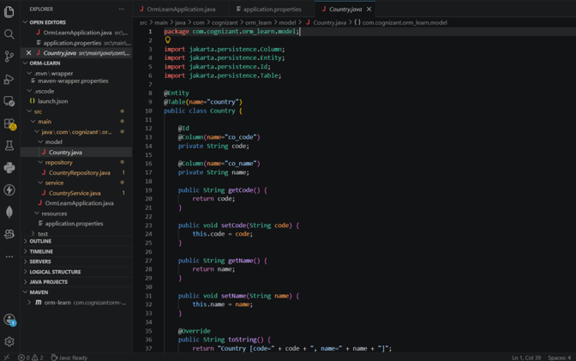

Exercise 2: Repository Layer

File: CountryRepository.java
Java
package com.cognizant.ormlearn.repository;import org.springframework.data.jpa.repository.JpaRepository;import org.springframework.stereotype.Repository;import com.cognizant.ormlearn.model.Country;
@Repositorypublic interface CountryRepository extends JpaRepository<Country, String> {
}
Output Screenshot:
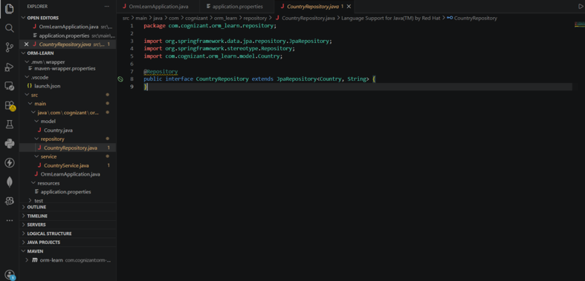

Exercise 3: Service Layer

File: CountryService.java
Java
package com.cognizant.ormlearn.service;import java.util.List;import org.springframework.beans.factory.annotation.Autowired;import org.springframework.stereotype.Service;import jakarta.transaction.Transactional;import com.cognizant.ormlearn.model.Country;import com.cognizant.ormlearn.repository.CountryRepository;
@Servicepublic class CountryService {
@Autowired
private CountryRepository countryRepository;

@Transactional
public List<Country> getAllCountries() {
return countryRepository.findAll();
}
}
Output Screenshot:
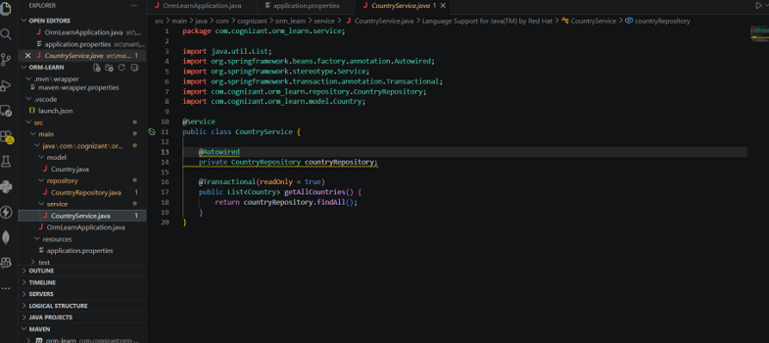

Exercise 4: Execution and Testing

File: OrmLearnApplication.java
Java
package com.cognizant.ormlearn;import java.util.List;import org.slf4j.Logger;import org.slf4j.LoggerFactory;import org.springframework.boot.SpringApplication;import org.springframework.boot.autoconfigure.SpringBootApplication;import org.springframework.context.ApplicationContext;import com.cognizant.ormlearn.model.Country;import com.cognizant.ormlearn.service.CountryService;
@SpringBootApplicationpublic class OrmLearnApplication {
private static final Logger LOGGER = LoggerFactory.getLogger(OrmLearnApplication.class);
private static CountryService countryService;

public static void main(String[] args) {
ApplicationContext context = SpringApplication.run(OrmLearnApplication.class, args);
countryService = context.getBean(CountryService.class);
testGetAllCountries();
}
private static void testGetAllCountries() {
List<Country> countries = countryService.getAllCountries();
LOGGER.debug("countries={}", countries);
}
}
Output Screenshot: 